PORTLAND MUSEUM
ACCESSIBILITY GUIDE

This guide does not contain personal opinions as to our suitability for
those with access needs, but aims to accurately describe the facilities and
services we offer our visitors.
The museum welcomes feedback for further inclusions into subsequent
editions of this guide. Please email us at administrator@portlandmuseum.co.uk

1. Introduction
• Portland Museum is located on the Isle of Portland in Dorset, part of the Jurassic Coast
World Heritage site. It is housed in two 17th century thatched cottages and a gallery.
• Volunteers and members of staff are on hand should you have any questions or require
assistance.
• Portland Museum is located at 217 Wakeham, Portland, Dorset DT5 1HS, which is at the
south end of the hamlet of Wakeham.
• We look forward to welcoming you. If you have any enquiries, please call the administrator
on 01305 821804 or email us at administrator@portlandmuseum.co.uk

2.Accessibility At A Glance
2.1 Level Access
• Due to the historic nature of the cottages, there is very little level access. Each building is discussed in the following pages.
2.2 Hearing
• There are no augmented hearing aids or museum taped loops available. Many of the displays have textual information and some, transcriptions of A/V displays.
2.3 Visual
• Some door heights, entrance steps, and low lighting may prove challenging for the visually impaired. Steps are indicated by a white painted stripe on entrances and exits.
2.4 General
• We have a complimentary ticket policy for companions.
• There are no level access toilets available and no wheelchair accessible toilet services.
• Assistance dogs only are welcome. A water bowl is available upon request.

3.Getting Here
3.1 Travel by Public Transport
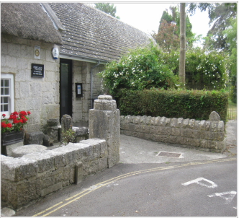
•In the spring and autumn, you cannot get directly to the museum by either bus or train.
• The closest bus stop is in the centre of Easton, a distance of .5 miles.
• In the summer, a bus stops outside the museum in Wakeham every two hours.
• Please check the bus service FIRSTSTOP online for details.
• The nearest train station is in the town of Weymouth, 7.2 miles away.

3.2 Travel by Taxi
• A local taxi service that provides accessible taxi services is Nicky’s Taxis: (01305) 821000. Pre-booking is recommended.
• Folding wheelchairs are easily accommodated in most of their cabs but fixed wheelchairs must have wheelchair accessible taxis.

3.3 Parking
• The nearest drop-off point is at the museum entrance off Church Ope Road.
• This road is a narrow, single car road.
• Museum parking is in an un-serviced municipal parking lot 200m from the front door.
• The parking lot is not paved, slightly sloped, and can be both muddy and slippery in inclement weather.
• There are no disabled spaces.
4.Arrival
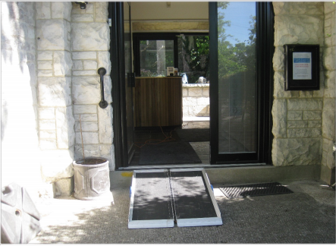
4.1. Path to Main Entrance
• From Wakeham, facing south, turn left into Church Ope Road. The museum entrance is the first door on the left.
• Level access from the road ends at the door.

4.2 Accessibility ramp
• Our portable ramp can be laid at the front door providing a gentle slope to the reception area.
• Please request that this ramp be installed prior to arrival.

4.3 Door Width
• The main door opens inwards and is 910mm wide.

5. Reception/Gift Shop

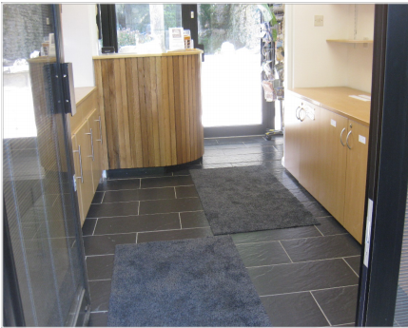
5.1 The Reception Desk
• The access is level to the entrance desk.
• This hard surface area is partially carpeted.

5.2 Gift Shop
• Both sides are lined with items from the museum’s gift shop.
• The entry way past the entrance desk is 750mm wide.

5.3 Reception Area and Gift Shop Exit
• The entry door to the East and West Galleries is to the right and is 750mm wide. The floor has no barrier to entry.

5A- Reception area Rear Exit

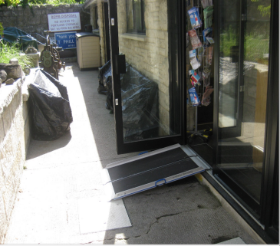
• The reception area also exits directly on to the rear
walkway.
• The door is 800mm wide and there is drop of 180mm to
the walkway.
• This walkway leads to Avice’s Cottage, Marie Stopes’
Cottage, and the garden.
• It is recommended that the ramp be installed at the rear
door to facilitate wheelchair access/egress.

6.West Gallery
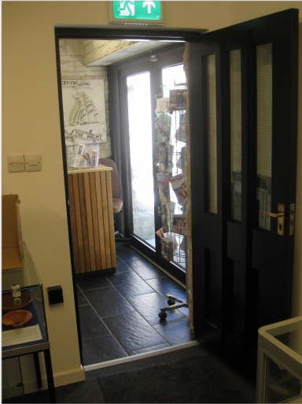

6.1 Access
• The floor is level and there are no barriers to movement. Most cabinets are 900mm high.
• Please email/call to obtain details of current displays.

7.East Gallery

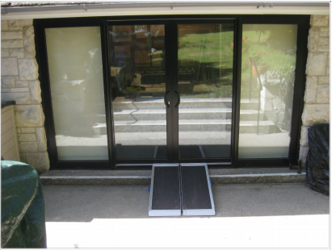
7.1 Access
• The floor is level throughout and cabinets are 900/950mm high.
• The exit from the East Gallery is either back through the entrance or to the outside walkway. This exit has double patio doors and a two-step drop of 60mm and 100mm. It is advised that the ramp be moved here to facilitate the movement of wheelchairs to the outside.
• Please email/call to obtain details of current displays.

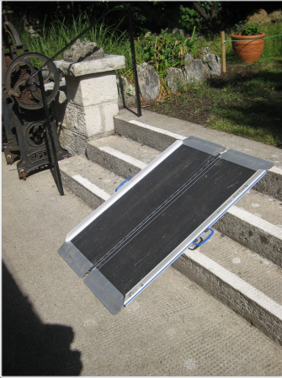
8.The Garden

8.1 Access
• The garden is a grassy sloped area that is accessed from the walkway by mounting three steps of 150mm each.
• The portable ramp can be used to bridge these steps but it is still very steep and some unaided wheelchairs may not be able to climb the ramp.
• The ground is not evenly grassed and wheelchairs may find it difficult to traverse the ground.

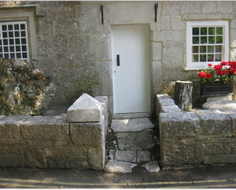
9.Avice’s Cottage

9.1 Access
• A newly refurbished door on to Church Ope Road has recently been completed but the original floor inside the cottage is very uneven.
• The roadside doorway is narrow and the stone entrance path is not level. The door is 730 mm wide.
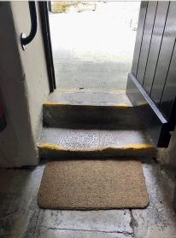
• The doorway on the opposite side of the cottage (pictured to the right) has a handrail, is 710 mm wide, and has two steps of 120 and 190 mm rising onto the rear walkway and patio/courtyard area.

9.2 Exits
• The exit for wheelchairs is the same as the entry, above.

10.The Patio and Customer Toilet

10.1 Access
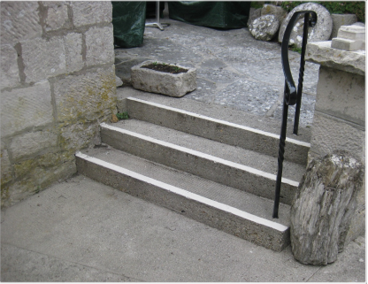
• There are three steps rising 150,170, and 150 mm to the main patio area.
• The portable ramp can be employed to provide access but it is a steep climb and some unaided wheelchairs may have difficulty.
• The surface is Portland Stone and sloped gently towards the steps. This surface can be slippery in inclement weather.
• The patio leads to our purpose-built customer toilet depicted on the next page which is not suitable for wheelchair access.

10. Customer Toilets
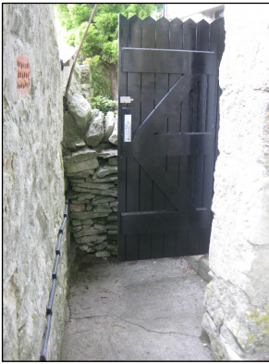
Sharp Right-Angled Access Narrow and Confined Space
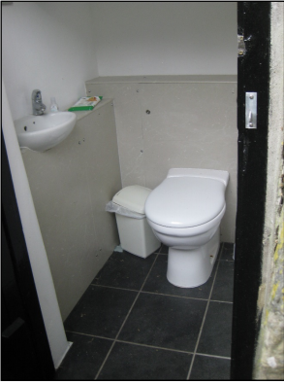
11. Marie Stopes’ Cottage

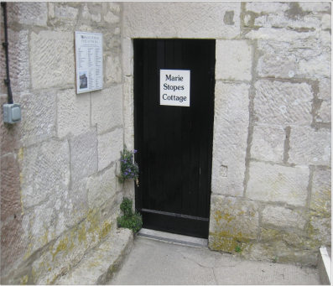

11.2 Access – Through Porch
• A low door (pictured on the right) which is 750mm wide provides access to Marie Stopes’ Cottage. Some wheelchairs are able to pass through this doorway.
• Please email/call to obtain details of current displays.

